Multiple AvKARE Labeled Ophthalmic Products CONSUMER-LEVEL RECALL - CUSTOMER CARE TALK TRACK

Background Information: On April 29, 2025, BRS Analytical Service, LLC initiated a consumer-level recall of Multiple AvKARE Labeled Ophthalmic Products. This recall was issued due to manufacturing cGMP deviations identified during an audit by FDA. Health Hazard to the user is unknown, cGMP deviations may lead to products of unacceptable quality, and it is not possible to rule out patient risks resulting from use of these products.

This recall affects:

Product | NDC | Lot #/Exp. Date
Artificial Tears Ophthalmic Solution | 50268-0043-15 | 126 Exp. 10/26/25
Artificial Tears Ophthalmic Solution | 50268-0043-15 | 127 Exp. 10/30/25
Artificial Tears Ophthalmic Solution | 50268-0043-15 | 128 Exp. 11/02/25
Artificial Tears Ophthalmic Solution | 50268-0043-15 | 129 Exp. 11/06/25
Artificial Tears Ophthalmic Solution | 50268-0043-15 | 162 Exp. 05/09/26
Artificial Tears Ophthalmic Solution | 50268-0043-15 | 163 Exp. 05/14/26
Artificial Tears Ophthalmic Solution | 50268-0043-15 | 164 Exp. 05/20/26
Artificial Tears Ophthalmic Solution | 50268-0043-15 | 165 Exp. 05/23/26
Artificial Tears Ophthalmic Solution | 50268-0043-15 | 166 Exp. 05/29/26
Artificial Tears Ophthalmic Solution | 50268-0043-15 | 167 Exp. 06/03/26
Artificial Tears Ophthalmic Solution | 50268-0043-15 | 168 Exp. 06/06/26
Artificial Tears Ophthalmic Solution | 50268-0043-15 | 169 Exp. 06/10/26
Artificial Tears Ophthalmic Solution | 50268-0043-15 | 170 Exp. 06/13/26
Artificial Tears Ophthalmic Solution | 50268-0043-15 | 193 Exp. 10/07/26
Artificial Tears Ophthalmic Solution | 50268-0043-15 | 194 Exp. 10/10/26
Artificial Tears Ophthalmic Solution | 50268-0043-15 | 195 Exp. 10/14/26
Artificial Tears Ophthalmic Solution | 50268-0043-15 | 196 Exp. 10/17/26
Artificial Tears Ophthalmic Solution | 50268-0043-15 | 197 Exp. 10/21/26
Artificial Tears Ophthalmic Solution | 50268-0043-15 | 198 Exp. 10/24/26
Artificial Tears Ophthalmic Solution | 50268-0043-15 | 199 Exp. 10/30/26
Carboxymethylcellulose Sodium Ophthalmic Gel 1% | 50268-0066-15 | 114 Exp. 09/04/25
Carboxymethylcellulose Sodium Ophthalmic Gel 1% | 50268-0066-15 | 115 Exp. 09/06/25
Carboxymethylcellulose Sodium Ophthalmic Gel 1% | 50268-0066-15 | 116 Exp. 09/10/25
Carboxymethylcellulose Sodium Ophthalmic Gel 1% | 50268-0066-15 | 207 Exp. 12/05/26
*Carboxymethylcellulose Sodium Ophthalmic Solution 0.5% | 50268-0068-15 | 104 Exp. 05/03/25
*Carboxymethylcellulose Sodium Ophthalmic Solution 0.5% | 50268-0068-15 | 108 Exp. 06/29/25
*Carboxymethylcellulose Sodium Ophthalmic Solution 0.5% | 50268-0068-15 | 109 Exp. 07/18/25
*Carboxymethylcellulose Sodium Ophthalmic Solution 0.5% | 50268-0068-15 | 110 Exp. 08/17/25
*Carboxymethylcellulose Sodium Ophthalmic Solution 0.5% | 50268-0068-15 | 111 Exp. 08/22/25
*Carboxymethylcellulose Sodium Ophthalmic Solution 0.5% | 50268-0068-15 | 112 Exp. 08/27/25
*Carboxymethylcellulose Sodium Ophthalmic Solution 0.5% | 50268-0068-15 | 113 Exp. 09/18/25
*Carboxymethylcellulose Sodium Ophthalmic Solution 0.5% | 50268-0068-15 | 125 Exp. 10/23/25
*Carboxymethylcellulose Sodium Ophthalmic Solution 0.5% | 50268-0068-15 | 130 Exp. 11/09/25
*Carboxymethylcellulose Sodium Ophthalmic Solution 0.5% | 50268-0068-15 | 131 Exp. 11/14/25
*Carboxymethylcellulose Sodium Ophthalmic Solution 0.5% | 50268-0068-15 | 132 Exp. 11/27/25
*Carboxymethylcellulose Sodium Ophthalmic Solution 0.5% | 50268-0068-15 | 133 Exp. 11/30/25
*Carboxymethylcellulose Sodium Ophthalmic Solution 0.5% | 50268-0068-15 | 134 Exp. 12/05/25
*Carboxymethylcellulose Sodium Ophthalmic Solution 0.5% | 50268-0068-15 | 135 Exp. 12/11/25
*Carboxymethylcellulose Sodium Ophthalmic Solution 0.5% | 50268-0068-15 | 136 Exp. 12/14/25
*Carboxymethylcellulose Sodium Ophthalmic Solution 0.5% | 50268-0068-15 | 137 Exp. 01/02/26
*Carboxymethylcellulose Sodium Ophthalmic Solution 0.5% | 50268-0068-15 | 139 Exp. 01/15/26
*Carboxymethylcellulose Sodium Ophthalmic Solution 0.5% | 50268-0068-15 | 140 Exp. 01/19/26
*Carboxymethylcellulose Sodium Ophthalmic Solution 0.5% | 50268-0068-15 | 141 Exp. 01/25/26
*Carboxymethylcellulose Sodium Ophthalmic Solution 0.5% | 50268-0068-15 | 151 Exp. 03/18/26
*Carboxymethylcellulose Sodium Ophthalmic Solution 0.5% | 50268-0068-15 | 152 Exp. 03/21/26
*Carboxymethylcellulose Sodium Ophthalmic Solution 0.5% | 50268-0068-15 | 153 Exp. 03/25/26
*Carboxymethylcellulose Sodium Ophthalmic Solution 0.5% | 50268-0068-15 | 154 Exp. 03/28/26
*Carboxymethylcellulose Sodium Ophthalmic Solution 0.5% | 50268-0068-15 | 155 Exp. 04/08/26
*Carboxymethylcellulose Sodium Ophthalmic Solution 0.5% | 50268-0068-15 | 156 Exp. 04/08/26
*Carboxymethylcellulose Sodium Ophthalmic Solution 0.5% | 50268-0068-15 | 157 Exp. 04/11/26
*Carboxymethylcellulose Sodium Ophthalmic Solution 0.5% | 50268-0068-15 | 160 Exp. 04/26/26
*Carboxymethylcellulose Sodium Ophthalmic Solution 0.5% | 50268-0068-15 | 180 Exp. 08/08/26
*Carboxymethylcellulose Sodium Ophthalmic Solution 0.5% | 50268-0068-15 | 181 Exp. 08/12/26
*Carboxymethylcellulose Sodium Ophthalmic Solution 0.5% | 50268-0068-15 | 182 Exp. 08/18/26
*Carboxymethylcellulose Sodium Ophthalmic Solution 0.5% | 50268-0068-15 | 183 Exp. 08/21/26
*Carboxymethylcellulose Sodium Ophthalmic Solution 0.5% | 50268-0068-15 | 184 Exp. 08/26/26
*Carboxymethylcellulose Sodium Ophthalmic Solution 0.5% | 50268-0068-15 | 185 Exp. 09/04/26
*Carboxymethylcellulose Sodium Ophthalmic Solution 0.5% | 50268-0068-15 | 186 Exp. 09/09/26
*Carboxymethylcellulose Sodium Ophthalmic Solution 0.5% | 50268-0068-15 | 187 Exp. 09/16/26
*Carboxymethylcellulose Sodium Ophthalmic Solution 0.5% | 50268-0068-15 | 189 Exp. 09/21/26
*Carboxymethylcellulose Sodium Ophthalmic Solution 0.5% | 50268-0068-15 | 190 Exp. 09/25/26
*Carboxymethylcellulose Sodium Ophthalmic Solution 0.5% | 50268-0068-15 | 191 Exp. 09/28/26
*Carboxymethylcellulose Sodium Ophthalmic Solution 0.5% | 50268-0068-15 | 192 Exp. 10/02/26
*Carboxymethylcellulose Sodium Ophthalmic Solution 0.5% | 50268-0068-15 | 208 Exp. 12/11/26
*Carboxymethylcellulose Sodium Ophthalmic Solution 0.5% | 50268-0068-15 | 209 Exp. 12/16/26
*Carboxymethylcellulose Sodium Ophthalmic Solution 0.5% | 50268-0068-15 | 212 Exp. 01/15/24
*Carboxymethylcellulose Sodium Ophthalmic Solution 0.5% | 50268-0068-15 | 213 Exp. 01/21/27
*Carboxymethylcellulose Sodium Ophthalmic Solution 0.5% | 50268-0068-15 | 214 Exp. 01/24/27
*Carboxymethylcellulose Sodium Ophthalmic Solution 0.5% | 50268-0068-15 | 215 Exp. 02/02/27
*Carboxymethylcellulose Sodium Ophthalmic Solution 0.5% | 50268-0068-15 | 216 Exp. 02/04/27
*Carboxymethylcellulose Sodium Ophthalmic Solution 0.5% | 50268-0068-15 | 224 Exp. 03/27/27
Lubricant Eye Drops Solution | 50268-0126-15 | 117 Exp. 09/20/25
Lubricant Eye Drops Solution | 50268-0126-15 | 118 Exp. 09/25/25
Lubricant Eye Drops Solution | 50268-0126-15 | 119 Exp. 09/27/25
Lubricant Eye Drops Solution | 50268-0126-15 | 121 Exp. 10/05/25
Lubricant Eye Drops Solution | 50268-0126-15 | 161 Exp. 05/01/26
Lubricant Eye Drops Solution | 50268-0126-15 | 171 Exp. 06/18/26
Lubricant Eye Drops Solution | 50268-0126-15 | 172 Exp. 06/24/26
Lubricant Eye Drops Solution | 50268-0126-15 | 174 Exp. 07/01/26
Lubricant Eye Drops Solution | 50268-0126-15 | 175 Exp. 07/08/26
Lubricant Eye Drops Solution | 50268-0126-15 | 200 Exp. 11/05/26
Lubricant Eye Drops Solution | 50268-0126-15 | 201 Exp. 11/10/26
Lubricant Eye Drops Solution | 50268-0126-15 | 202 Exp. 11/13/26
Lubricant Eye Drops Solution | 50268-0126-15 | 203 Exp. 11/18/26
Lubricant Eye Drops Solution | 50268-0126-15 | 204 Exp. 11/21/26
Lubricant Eye Drops Solution | 50268-0126-15 | 205 Exp. 11/25/26
Lubricant Eye Drops Solution | 50268-0126-15 | 206 Exp. 12/02/26
Lubricant Eye Drops Solution | 50268-0126-15 | 219 Exp. 02/24/27
Lubricant Eye Drops Solution | 50268-0126-15 | 221 Exp. 03/02/27
Lubricant Eye Drops Solution | 50268-0126-15 | 222 Exp. 03/05/27
*Polyvinyl Alcohol Ophthalmic Solution | 50268-0678-15 | 120 Exp. 10/02/25
*Polyvinyl Alcohol Ophthalmic Solution | 50268-0678-15 | 122 Exp. 10/09/25
*Polyvinyl Alcohol Ophthalmic Solution | 50268-0678-15 | 123 Exp. 10/12/25
*Polyvinyl Alcohol Ophthalmic Solution | 50268-0678-15 | 124 Exp. 10/16/25
*Polyvinyl Alcohol Ophthalmic Solution | 50268-0678-15 | 138 Exp. 10/08/26
*Polyvinyl Alcohol Ophthalmic Solution | 50268-0678-15 | 142 Exp. 12/09/26
*Polyvinyl Alcohol Ophthalmic Solution | 50268-0678-15 | 143 Exp. 02/01/26
*Polyvinyl Alcohol Ophthalmic Solution | 50268-0678-15 | 144 Exp. 02/07/26
*Polyvinyl Alcohol Ophthalmic Solution | 50268-0678-15 | 145 Exp. 02/12/26
*Polyvinyl Alcohol Ophthalmic Solution | 50268-0678-15 | 146 Exp. 02/15/26
*Polyvinyl Alcohol Ophthalmic Solution | 50268-0678-15 | 147 Exp. 02/21/26
*Polyvinyl Alcohol Ophthalmic Solution | 50268-0678-15 | 148 Exp. 02/27/26
*Polyvinyl Alcohol Ophthalmic Solution | 50268-0678-15 | 149 Exp. 03/04/26
*Polyvinyl Alcohol Ophthalmic Solution | 50268-0678-15 | 150 Exp. 03/11/26
*Polyvinyl Alcohol Ophthalmic Solution | 50268-0678-15 | 158 Exp. 04/15/26
*Polyvinyl Alcohol Ophthalmic Solution | 50268-0678-15 | 159 Exp. 04/22/26
*Polyvinyl Alcohol Ophthalmic Solution | 50268-0678-15 | 176 Exp. 07/24/26
*Polyvinyl Alcohol Ophthalmic Solution | 50268-0678-15 | 177 Exp. 07/28/26
*Polyvinyl Alcohol Ophthalmic Solution | 50268-0678-15 | 178 Exp. 07/31/26
*Polyvinyl Alcohol Ophthalmic Solution | 50268-0678-15 | 179 Exp. 08/05/26

*Carried at CVS Caremark Mail Order Service

Customer Care Talk Track:

** Please ensure to disposition all recall calls to code “1116” **

Clinical Care Service/Specialty Pharmacy Talk Track

Clinical Care Technicians - Please ensure to disposition all recall calls to code “1456”
Clinical Care Pharmacists - Please ensure to disposition all recall calls to code “1408”

Q# | Question | Action | Answer
1 | I heard that there is recall with my AvKARE Labeled Ophthalmic Product. Can you give me more information? | Note: Check PeopleSafe to determine if the medication is from Mail or Specialty Pharmacy | If the medication was dispensed from… | Then say…
1 |  |  | Mail Order | - Yes, I can.  - Proceed to Q2
1 |  |  | Specialty | While in PeopleSafe, determine the phone number of the dispensing Specialty pharmacy and transfer the call.  A: Yes, I can. Please hold while I transfer you to your Specialty Pharmacy.

Customer Care/Specialty Talk Track Clinical Care Service/Specialty Pharmacy Talk Track
2 | Why is there a recall? What is wrong with the product? |  | April 29, 2025, BRS Analytical Service, LLC initiated a consumer-level recall of Multiple AvKARE Labeled Ophthalmic Products. This recall was issued due to manufacturing cGMP deviations identified during an audit by FDA.  For more information, call AvKARE toll-free at 1-855-361-3993. You may also call the United States Food and Drug Administration (FDA) toll-free at 1-888-INFO-FDA (1-888-463-6332) or visit www.fda.gov.
3 | May I return the rest of the product that I have? | Determine if the patient is affected by this recall | First, let’s determine if you are affected by this recall:
3 | May I return the rest of the product that I have? | Determine if the patient is affected by this recall | If the product was dispensed in… |  | Then say...
3 | May I return the rest of the product that I have? | Determine if the patient is affected by this recall | Manufacturer’s Package |  | - Check the lot number. The lot number is on the bottom of the package.  - If your product is not from this affected lot number, it is not affected by this recall.  If your product is from this affected lot number, CVS Caremark® Mail Service Pharmacy/Specialty Pharmacy will send you replacement product and a postage-paid envelope to return the affected product. If you received any recalled product from your retail pharmacy, please contact the pharmacy that filled your prescription for more information including return instructions.  Please note: If the member received recalled product, please submit a damaged bottle reship order and indicate the amount of replacement product to be sent. Please make sure to request call tag.
3 | May I return the rest of the product that I have? | Determine if the patient is affected by this recall | Pharmacy Bottle |  | CVS Caremark® Mail Service Pharmacy/Specialty Pharmacy will send you replacement product and a postage-paid envelope to return the affected product. If you received any recalled product from your retail pharmacy, please contact the pharmacy that filled your prescription for more information including return instructions.  Please note: If the member received recalled product, please submit a damaged bottle reship order and indicate the amount of replacement product to be sent. Please make sure to request call tag.
4 | Should I stop using my product? |  | If the medication was dispensed from… |  | Then say…
4 | Should I stop using my product? |  | Mail Order |  | Customer Care:  Please hold while I transfer you to one of our Clinical Counseling Clinicians.  Clinical Care Service:  You should not use any of the AvKARE labeled ophthalmic products that is affected by this recall. Please call your doctor right away for advice if you might be using affected product. Your doctor knows your medical history and can tell you what to do next. If you need a prescription for a different product, please contact your doctor.
4 | Should I stop using my product? |  | Specialty |  | Customer Care:  Please hold while I transfer you to your Specialty Pharmacy.  Clinical Care Service:  You should not use any of the AvKARE Labeled ophthalmic products that is affected by this recall. Please call your doctor right away for advice if you might be using affected product. Your doctor knows your medical history and can tell you what to do next. If you need a prescription for a different product, please contact your doctor.
5 | Will I receive credit for the product I return? |  | Your insurance will be credited for any affected product returned to us. We will replace the affected product with unaffected product. You will not be charged any additional copayments.
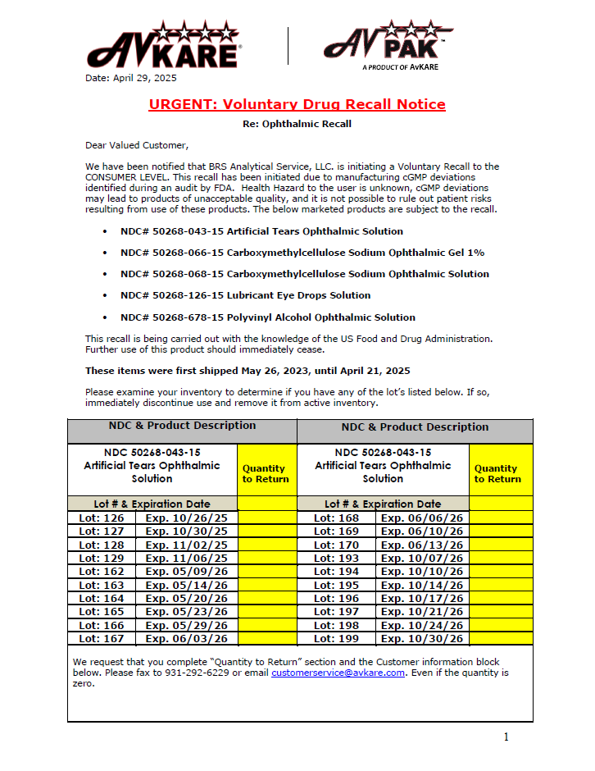

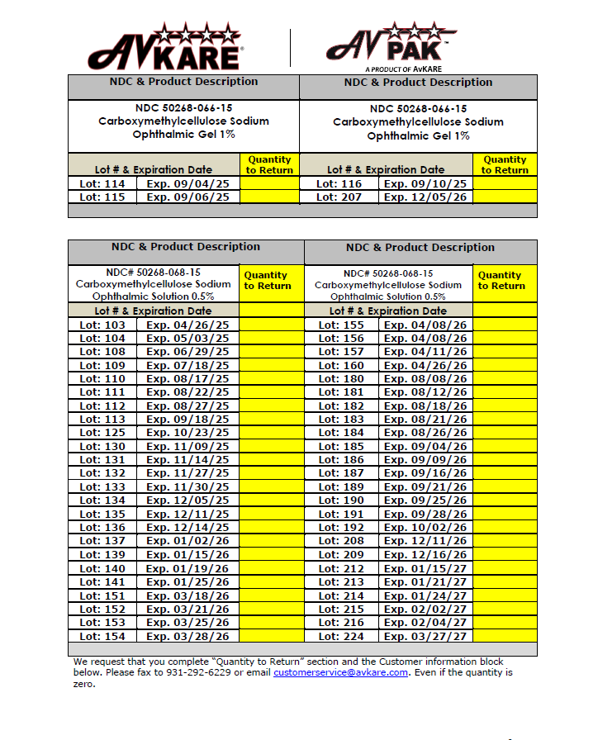
Top of the Document

Not to Be Reproduced or Disclosed to Others without Prior Written Approval
ELECTRONIC DATA = OFFICIAL VERSION / PAPER COPY = INFORMATIONAL ONLY

